**Experiment report**

Course Name : Electrical Circuits

Course Code : CSE209 LAB

Section No : 04

Experiment No : 07

Experiment name : DC Circuit Analysis in PSpice using Source and

Resistance Sweep

**Submitted to**

Course instructor : Rashedul Amin Tuhin

Senior lecturer

Computer science and engineering

**Submitted by**

Name: Apurba Roy Ajay

Student’s ID : 2018-3-60-063

Department : Computer science and engineering

**Date of report submission : /09/2020**

**Experiment Title: DC Circuit Analysis in PSpice using Source and Resistance Sweep.**

**Objectives:** To analyze DC circuit in PSpice by seeping source and resistance and to verify maximum power transfer theorem.

**Circuit Diagrams:**

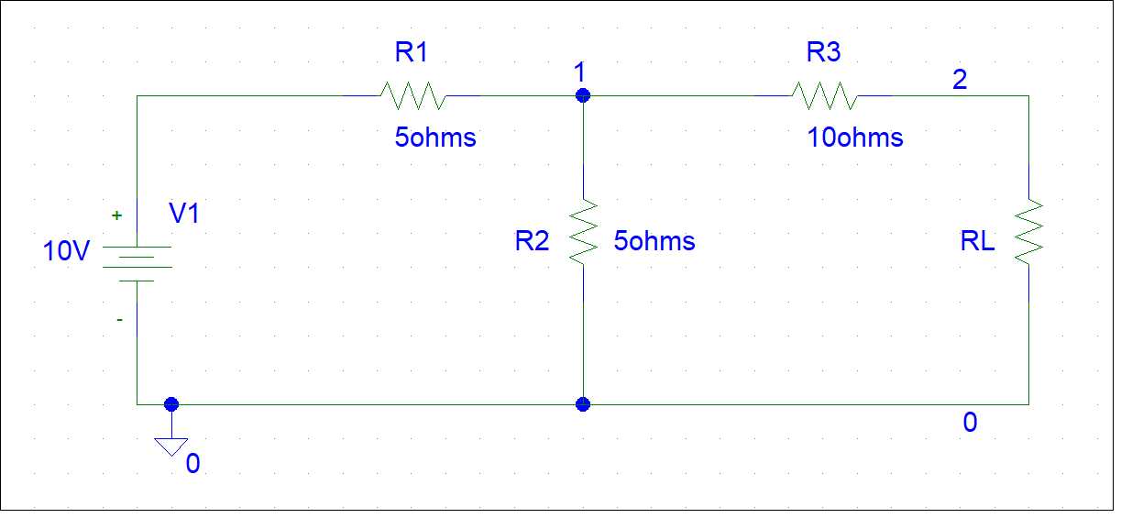

Figure 1. Example circuit

**Experimental Datasheet:**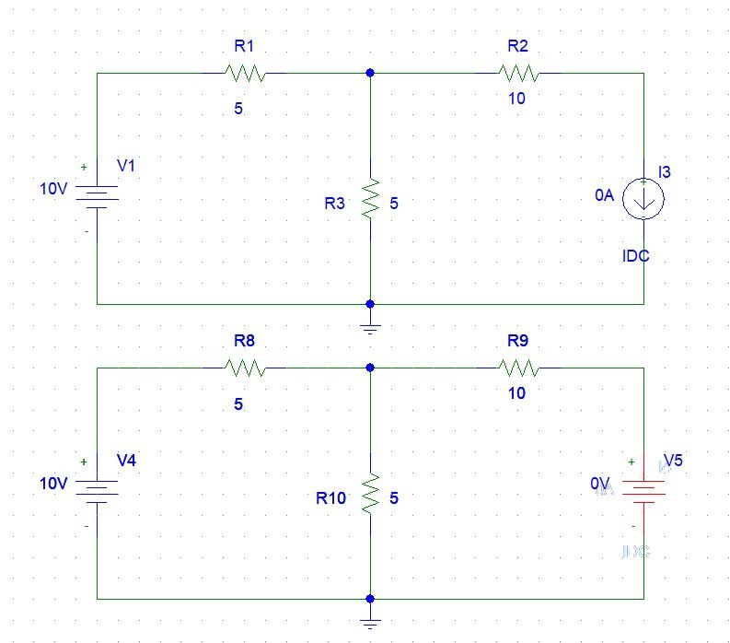

$$E_{th}=V_{0c}=5V$$

$$R_{th}=\frac{V_{oc}}{I_{sc}}=0.0125kΩ$$

$${R_{L}=R}_{th}=0.0125kΩ$$

$$P_{LMAX}=\frac{V_{th}}{4R_{th}}=\frac{25}{4*0.0125}=500Watt$$

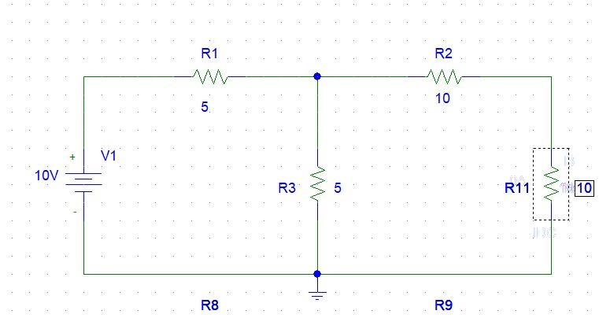

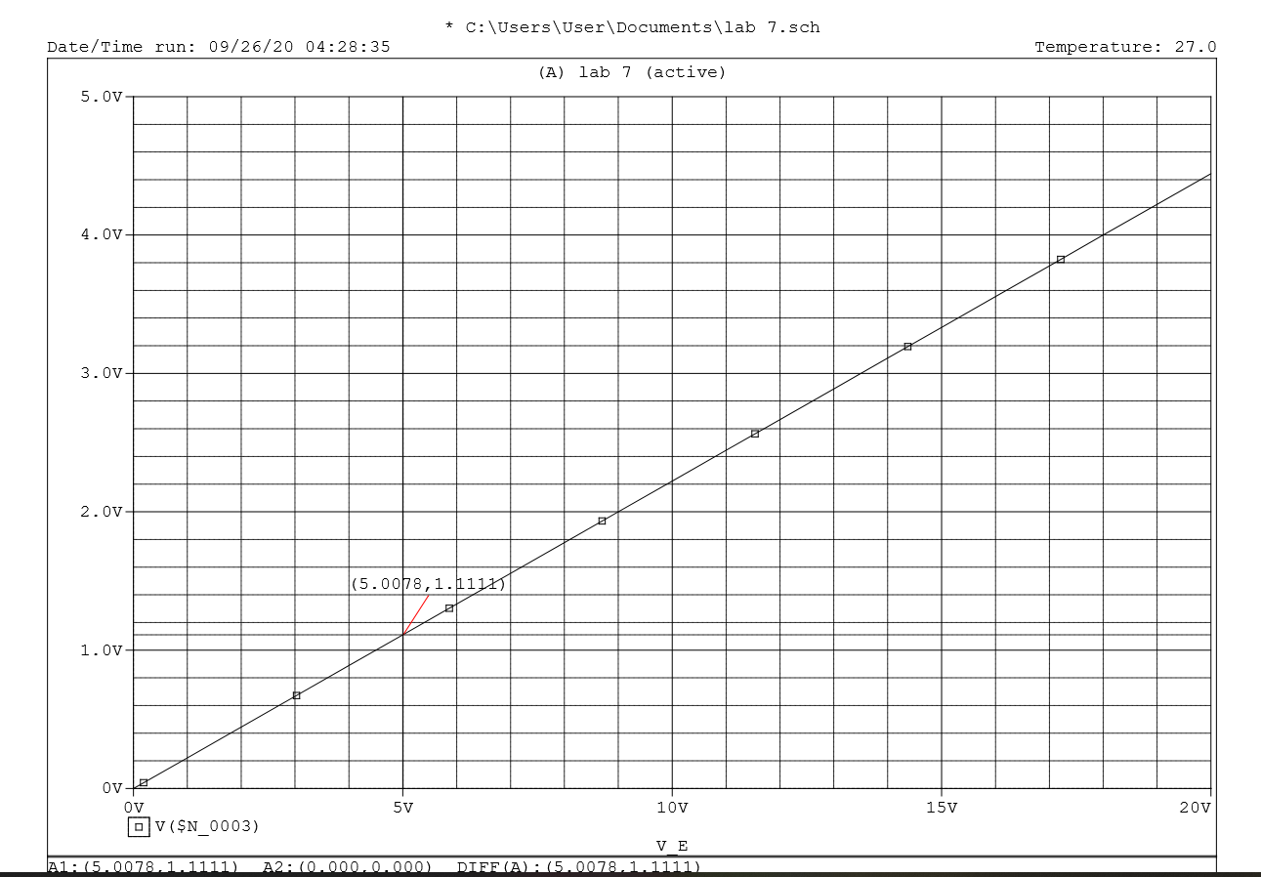

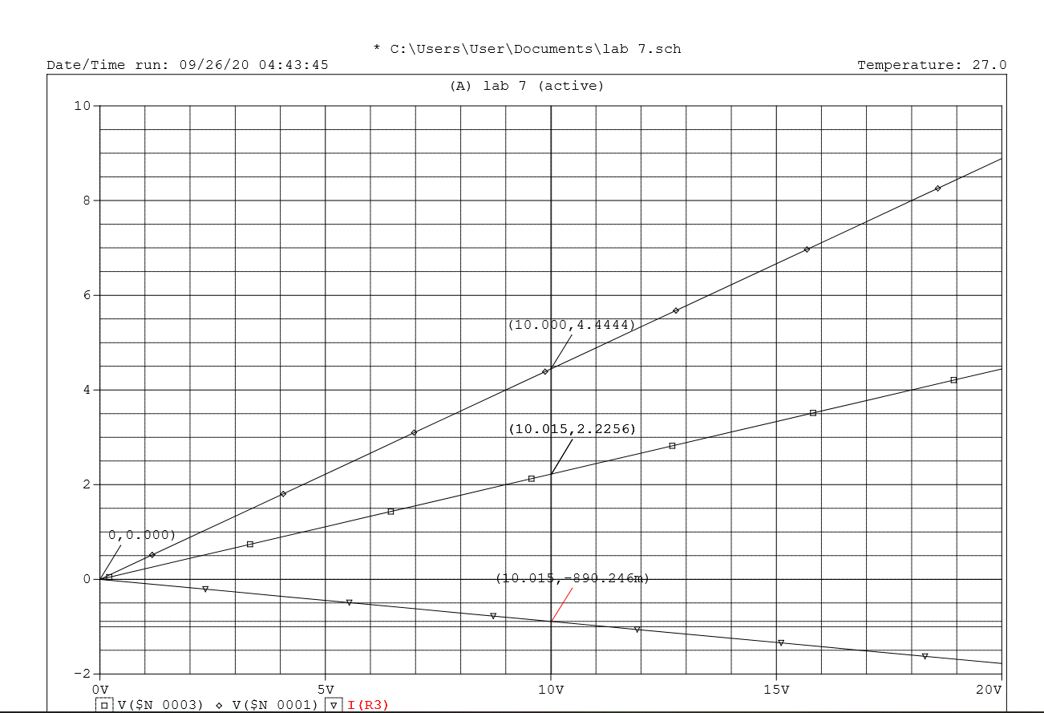

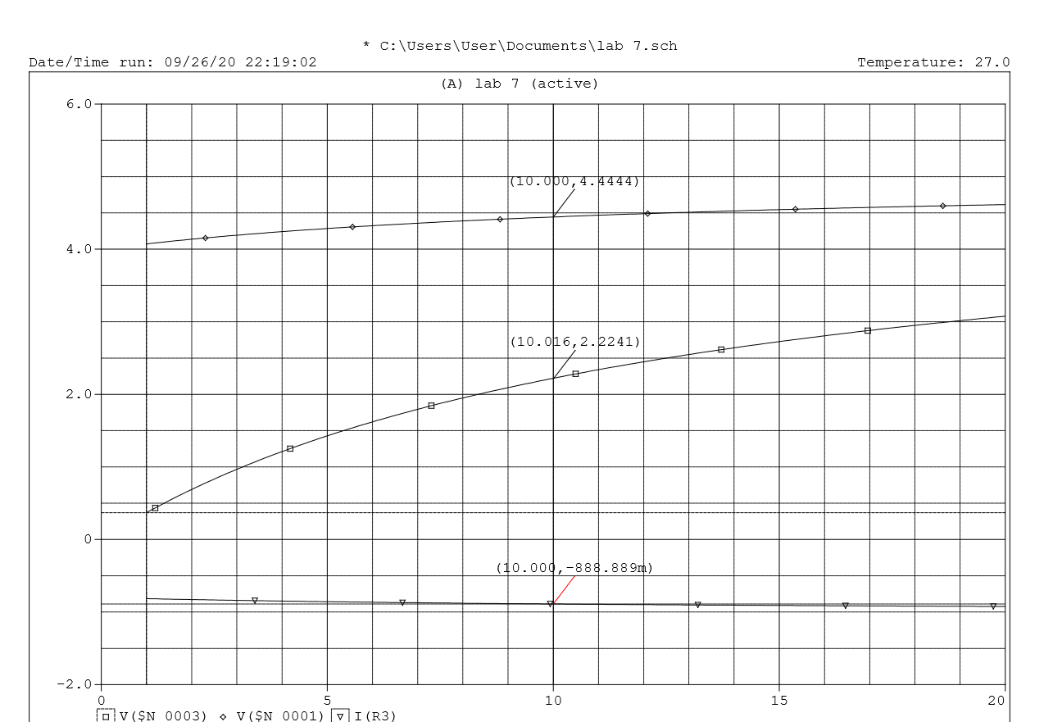

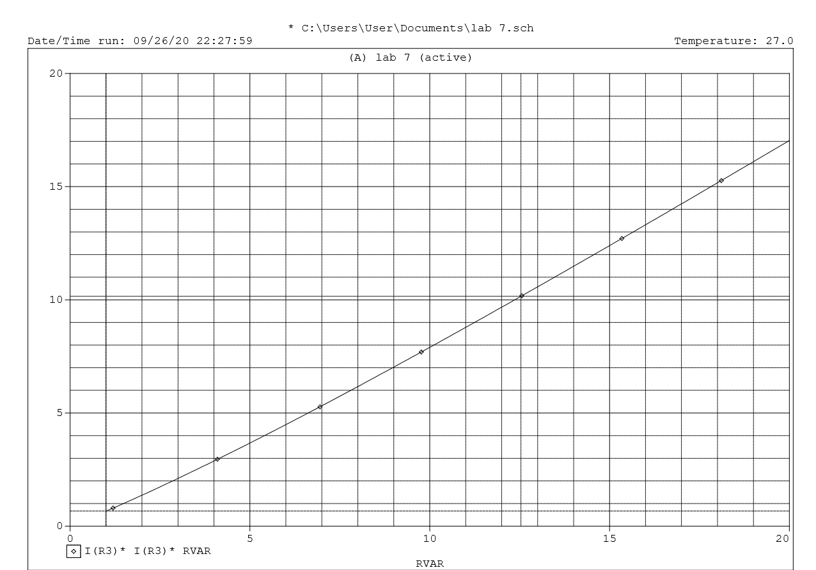

**Discussion and Analysis:**

Pre-lab data:

Theoretically calculated values are ${ R}_{L}$ = 12.5Ω, V(1) = 4.5V, $V(2)$ =2.5V and I(R3) = 400mA

Experimental data:

Measured values are ${ R}_{L}$ = 12.5Ω, V(1) = 4.5V, V(2) = 2.5V and I(R3) = 400mA

There are no differences between the theoretical values and the experimental measured values. Pre-lab data and experimental data are same.

**Answer to the Post Lab Questions**

1. **Compare the values of V(1), V(2) and I(R3) obtained in steps 4 and 5(d).**

**Solution:**

From step 4,

V(1) = 4.4444V for 10V

V(2) = 2.2222V for 10V and

I(R3) = -888.88mA for 10V

From step 5(d),

V(1) = 4.4444V for 10V

V(2) = 2.2222V for 10V and

I(R3) = -888.88mA for 10V

Comparing the values of V(1), V(2) and I(R3) obtained in steps 4 and 5(d):

Step 4 values: V(1) = 4.4444, V(2) = 2.2222V, I(R3) = -888.88mA

Step 5(d) values: V(1) = 4.4444, V(2) = 2.2222V, I(R3) = -888.88mA

Comment: There are no differences between the step 4 values and step 5(d) values.

**Compare the load resistance RL for maximum power transfer obtained in steps 2 and 5(e).**

**Solution:**

From step 2,

Load resistance $R_{L}$ = 12.5 $Ω$

From step 5(e),

Load resistance $R_{L}$ = 12.5 $Ω$

Comparing the load resistance $R_{L}$ for maximum power transfer obtained in steps 2 and 5(e):

Step 2: Load resistance $R_{L}$ = 12.5 $Ω$

Step 5(e): Load resistance $R_{L}$ = 12.5 $Ω$

Comment: There are no differences between the step 2 value and step 5(e) value.

1. **Compare the theoretical solutions with the solutions obtained from PSpice and comment on any discrepancy.**

**Solution:**

Theoretical solution:

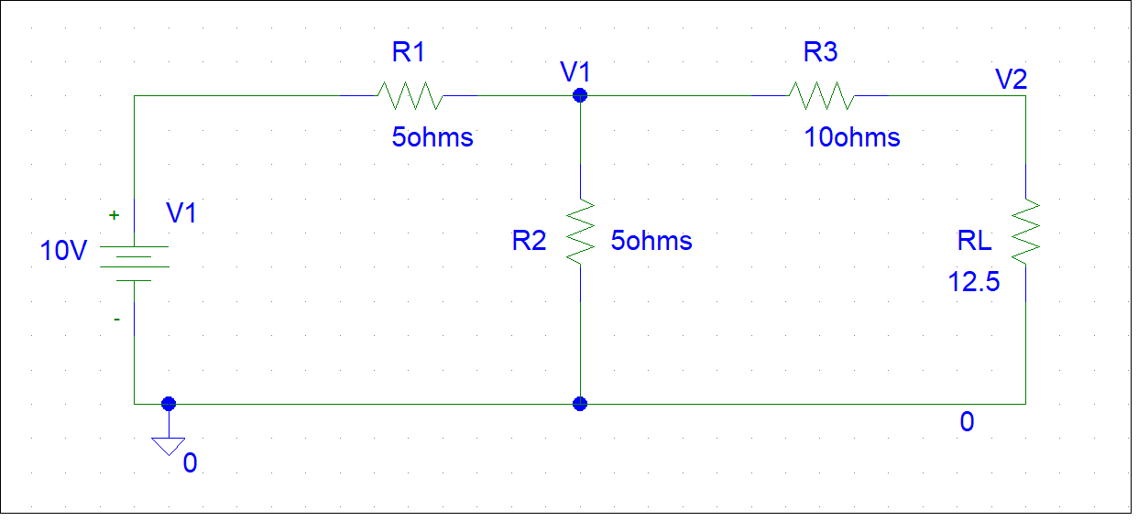

KCL at node $V_{1}$,

5 $V_{1}$- $V_{2}$ = 20………………………… (1)

KCL at node $V_{2}$,

- $12V_{1}$ + 22.5 $V_{2}$ = 0………………… (2)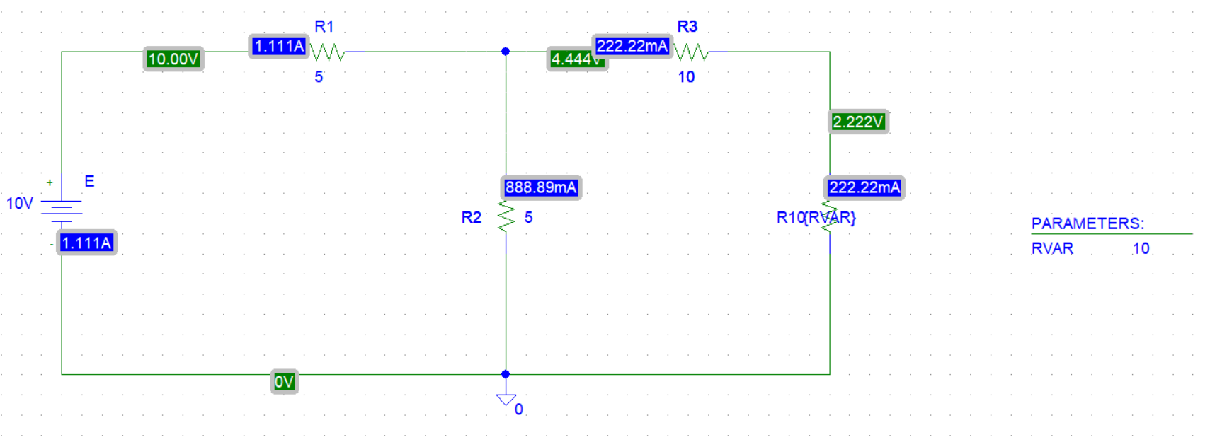From (1) and (2),

$V_{1}$ = 4.5V and $V_{2}$ =2.5V

So, V(1) = 4.5V and V(2) = 2.5V

KVL at mesh $I_{1}$,

10 $I_{1}$- $I_{2}$ = 10………………………… (3)

KVL at mesh $I_{2}$,

-5 $I_{1}$ + 27.5 $I_{2}$ = 0…………………… (4)

From (3) and (4),

$I_{1}$ = 1.1A and $I_{2}$ =200mA

So, I(R3) = 200mA

PSpice solution:

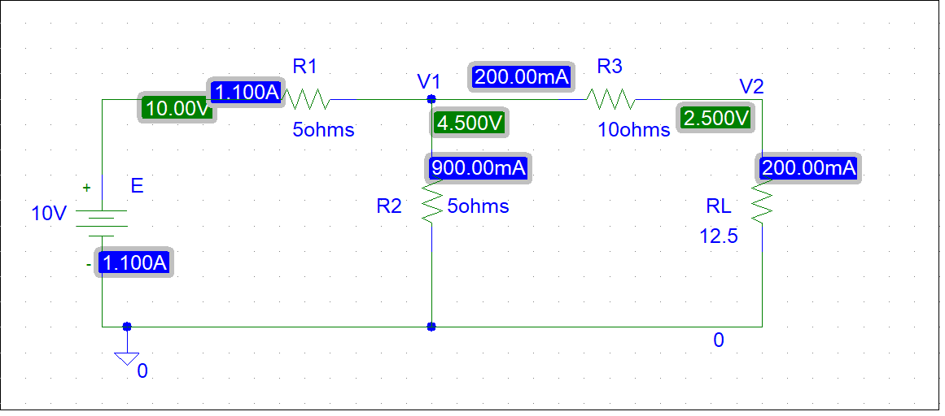

From PSpice:

V(1) = 4.500V

V(2) = 2.500V and

I(R3) = 200mA

Comparing the theoretical solutions with the solutions obtained from PSpice:

Theoretical solutions: V(1) = 4.5V, V(2) = 2.5V and I(R3) = 200mA

PSpice solutions: V(1) = 4.5V, V(2) = 2.5V and I(R3) = 200mA

Comment: There are no differences between the theoretical solutions and PSpice solutions.